Investment Policy Statement

Prepared for:

Emilio Conte

Location: Massachusetts, USA
Date: April 2025
Portfolio Type: Individual, Taxable Account Managed By: Giada Simbari (Portfolio Manager) Portfolio Value: $500,000
Return Objective: 6% – 13.74% annualized Maximum Acceptable Loss (1Y): 15% to 18%

This document is confidential and intended solely for the recipient.

This Investment Policy Statement summarizes the investment objectives, asset allocation strat- egy, risk tolerance, and governance framework for managing the client’s portfolio over the long term. (adapted from Investopedia, 2025)

Contents

- Executive Summary 4
- Scope and Purpose 4
  - Introduction and Purpose of the Document 4
  - Client Profile 4
  - General Investment Objectives 5
- Governance: Roles & Responsibilities 5
  - Portfolio Manager Responsibilities 5
  - Client Responsibilities 6
  - Review and Update of the IPS 6
- Investment, Return, and Risk Objectives 6
  - Return Objective 7
  - Risk Objective and Tolerance 7
  - Utility Maximization and Justification 8
  - Visualization 8
    - Pie Chart: Capital Allocation 8
    - Graph of Maximum Utility 9
    - Graph of Indifference Curve vs. Capital Allocation Line (CAL) 9
- Liquidity, Time Horizon, and Constraints 10
- Asset Allocation & Investment Philosophy 11
  - Investment Philosophy 11
  - Strategic Asset Allocation (SAA) 12
    - Security Allocation 12
- Permitted and Excluded Investments 13
- Risk Management and Performance Evaluation 14
  - Risk Management 14
  - Performance Evaluation and Benchmarking 15
    - Performance Evaluation Summary 16
  - Rebalancing Policy 16
- Appendix VI.A: Supporting Analysis 17
  - Exhibit 1: Capital Allocation 17
  - Exhibit 2: Asset Classes Allocation 19
  - Exhibit 3: Security Allocation 21
  - Exhibit 4: Data Securities 23
  - Exhibit 5:Data. Bond Duration & Convexity 26
- References 27
- Conclusion 28
- Works Cited 29

Executive Summary
This Investment Policy Statement (IPS) governs the strategic guidelines, objectives, and responsibilities pertaining to the investment portfolio of Mr. Emilio Conte. Mod- ern portfolio theory, inferred from extensive quantitative evaluation, affirms and collects all investment decisions under one coherent strategy aligned with the client’s profile, which is a 35-year-old professional with a long-term investment horizon. The client, Emilio C., has a medium-high risk tolerance (75/100) and the primary investment ob- jective is capital growth. The strategic outline proposes an allocation of 41. 46% to an active growth equity portfolio and of 58. 54% to risk-free assets, expecting a return of 13.74% and volatility of 13.96%. The IPS framework also defines the procedures for risk management, performance assessment, and policy review.

Scope and Purpose

Introduction and Purpose of the Document
This IPS is intended to exhaustively and unambiguously capture the governance, ob- jectives, constraints, and guidelines that a Portfolio Manager must adhere to while man- aging client assets. It is tactical and operational, so that each investment aligns with the client’s financial goals, the articulated risk appetite, and the investment horizon. The document aims to bring discipline to the portfolio management process and mitigate emotionally driven decisions during periods of market distress, such as panic selling and execution deviation from strategic vision. In addition, it describes how to reach defined financial milestones and provides an evidential basis to assess the set and achieved results.

Client Profile
The IPS has been created exclusively for Emilio Conte who is a 35-year-old investor and professional with more than 20 years of investment time horizon for retirement or substantial wealth accumulation goals. It is therefore "highly customized"to reflect the unique preferences and situation of this investor. Mr. Emilio C. demonstrates strong po- tential for earnings and savings in the upcoming years. The main financial objectivesves focus on maximizing wealth while pursuing capital growth. A standardized question- naire evaluated the client’s risk tolerance, which produced a score of 75 out of 100. The client demonstrates a medium-high risk profile because they accept substantial return volatility to achieve higher growth. The client’s age, along with accumulation targets, indicates that short- to medium-term liquidity requirements are minimal. Tax regula- tions for this investor follow standard procedures since no special legal or regulatory requirements or unique circumstances (including ESG preferences) need additional in- vestment restrictions beyond those in this document.

General Investment Objectives
The primary objective of this portfolio is to achieve the highest possible long-term capital growth, more specifically higher returns than conservative portfolios, by focusing on growth stock market opportunities. It also aims to maintain volatility at levels that match the client’s medium-high risk appetite.

Governance: Roles & Responsibilities

Portfolio Manager Responsibilities
The Portfolio Manager will perform both daily operations and strategic portfolio manage- ment tasks while following the guidelines in this IPS together with CFA Institute ethical and professional standards. The designated Portfolio Manager performs the following duties among others:
- Portfolio Construction and Implementation: The Strategic Asset Allocation serves as the foundation for implementing the initial portfolio structure.
- Security Selection: The portfolio active component consists of equity securities which the manager selects through growth investment philosophy and detailed quantitative analysis.
- Monitoring: The portfolio requires continuous observation to evaluate its perfor- mance against return and risk targets and benchmark standards. The portfolio un- dergoes regular evaluation (annual basis) for both its structure and performance assessment.
- Risk Management: The portfolio requires risk identification followed by risk mea- surement and risk management of Beta risk and specific risk and tracking error risk and concentration risk and interest rate risk when applicable through estab- lished metrics and methods.
- Trade Activities: The client receives efficient and effective trade execution services from the portfolio manager.
- Reporting:The client receives periodic reports (for example, quarterly) that include portfolio composition information along with absolute and relative performance data (including interest, dividends, transaction activity) and performance attribu- tion analysis and risk exposures.
- Communication and IPS Adherence: The client must receive immediate notifica- tion of any substantial changes in investment strategy, market outlook, or organi- zational structure of the manager or significant deviations from the IPS. This leads to ensuring full compliance with all provisions of this IPS

Client Responsibilities
The wealth management relationship needs active participation from clients to achieve success. The most important client responsibilities include:
- Information: The client must supply precise and thorough and current financial details about their wealth source.
- Review: The client must thoroughly review both the IPS before adoption and the periodic reports from the Portfolio Manager while understanding all content and implications.
- Communication: The Portfolio Manager needs to receive immediate notification from clients about important personal or financial changes that affect their lifestyle or investment strategy (For example lifestyle changes, unexpected financial events, investment objectives, or risk tolerance that might necessitate a review of the IPS or investment strategy.
- Final Approval: The client maintains the authority to approve the IPS and make significant modifications through recommendations and analyses from the Portfo- lio Manager.

Review and Update of the IPS
The IPS functions as a dynamic document which needs periodic assessments to maintain its appropriateness and relevance throughout time. The investment policy requires annual formal assessment as its minimum review frequency. The investment policy requires additional reviews whenever market conditions change, or economic outlook shifts, or the client’s financial situation or objectives change, or when regulatory changes occur. The Portfolio Manager must identify when up- dates are needed, then assess the effects of changes before suggesting suitable IPS modifications to the client. The client needs to discuss and approve all major IPS modifications before the implementation of these changes. The investment strategy stays aligned with both client needs and market conditions through this process.

Investment, Return, and Risk Objectives
The primary return objective for the complete portfolio is an expected annual return of 13.74%. This quantitative target derives directly from the capital allocation optimization analysis, which combines the risk-free asset with the identified optimal risky portfolio. It is the result of the specific capital allocation (41.46% in the risky portfolio and 58.54% in the risk-free asset) and reflects the return expectations of the individual components: a 4% return for the risk-free asset and an expected return of 27.49% for the underlying

risky portfolio, composed entirely of growth tech stocks. Historical data and current estimates suggest that an expected return of 27.49% for an equity portfolio is highly ambitious and implies high growth expectations and the assumption of significant risk. It is important to emphasize that achieving this return objective is inherently linked to accepting a commensurate level of market volatility, as detailed in the subsequent risk objective point.

Return Objective
The primary return objective for the complete portfolio is an expected annual return of 13.74%. This quantitative target derives directly from the capital allocation optimization analysis, which combines the risk-free asset with the identified optimal risky portfolio. This expected return is the result of the specific capital allocation (41.46% in the risky portfolio and 58.54% in the risk-free asset) and reflects the return expectations of the individual components: a 4% return for the risk-free asset and an expected return of 27.49% for the underlying risky portfolio, composed entirely of growth tech stocks. His- torical data and current estimates suggest that an expected return of 27.49% for an equity portfolio is highly ambitious and implies high growth expectations or the assump- tion of significant risk. It is important to emphasize that achieving this return objective is inherently linked to accepting a commensurate level of market volatility, as detailed in the subsequent risk objective point.

Risk Objective and Tolerance
The risk objective for the complete portfolio is quantitatively defined through its expected volatility, measured as standard deviation. A positive value of A, the Risk Aversion Co- efficient, indicates that the investor is risk-averse (prefers lower risk for the same return) and requires a premium (higher return) to take on more volatility. To understand how much capital is optimal to invest in the risky portfolio, according to the maximization of the client’s utility, the optimal weight model of the risky portfolio was used, that is, y*=41.465% invested in risky assets, while 58.54% in safe assets. These percentages communicate an implicit idea of how risk averse the client is. To understand the in- vestor’s risk profile, the inverse formula from portfolio theory was applied to derive the implied risk aversion coefficient:
𝐴 = 20 · 1 − Risk Tolerance Score
100

𝐴 = 20 · 1 − 75 = 5
100

For modeling purposes, this result is considered to align with a risk tolerance score of 75 out of 100, corresponding to a medium-high investor profile. This assumption allows for a more balanced approach in the utility calculation and portfolio construction.

Utility Maximization and Justification
The Expected utility (U) quantifies the level of satisfaction an investor derives from a particular portfolio, balancing expected return (which increases utility) against the disu- tility arising from risk, measured by variance and weighted by individual risk aversion
(A). The utility of the complete portfolio was calculated using the classical utility function:
𝑈 = 𝐸(𝑅_{𝑐}) − 1 𝐴 · 𝜎² = 0.1374 − 1 · 5 · (0.1396)² = 0.1374 − 0.04875 =
8.87%
2 ^{𝑐} 2
This value corresponds to a utility level of 8.87%, which reflects a very high satisfaction level for an investor with low risk aversion (A = 5), aligning with a balanced investment strategy. To summarize, this optimal point corresponds to the point of tangency between the Capital Allocation Line (the set of efficient investment opportunities achievable by combining the risk-free asset with the optimal risky portfolio) and the highest attain- able indifference curve for the client. For a risk-averse investor (A>0), these curves are convex and upward sloping. The Sharpe Ratio of the complete portfolio, 0.698, mea- sures the portfolio’s efficiency in terms of excess return (𝑅_{𝑐} − 𝑅 _{𝑓} ) per unit of total risk (𝜎_{𝑐}). Geometrically, it represents the slope of the Capital Allocation Line (CAL). A value greater than zero indicates that the portfolio offers a return higher than the risk-free rate. While the interpretation of what is considered “good” or “excellent” (e.g., >1, >2, >3) is relative and depends on market context and time horizon, a value of 0.698 suggests a reasonably efficient risk/return trade-off, especially given the high expected return of the risky component within the selected optimal portfolio.

Visualization

Pie Chart: Capital Allocation
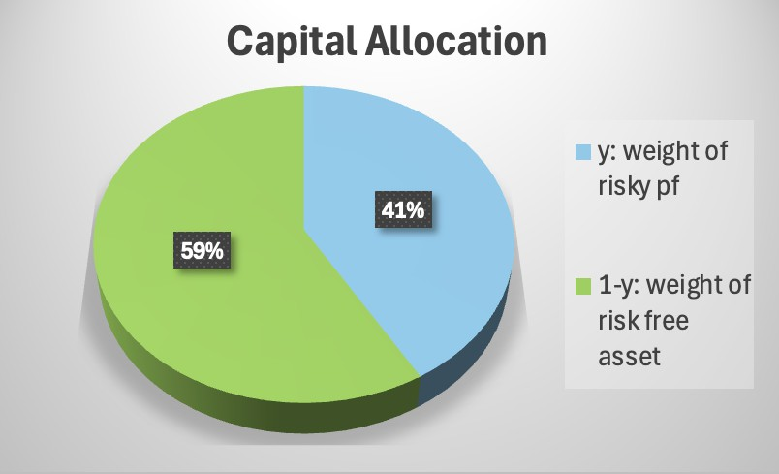
Figure 1: Capital Allocation Pie Chart: Risk-Free Asset vs Risky Portfolio

This chart provides an immediate understanding of the basic structure of the complete portfolio, highlighting the significant allocation to the risk-free asset despite the medium- high risk tolerance, due to the high volatility of the underlying risky portfolio.

Graph of Maximum Utility
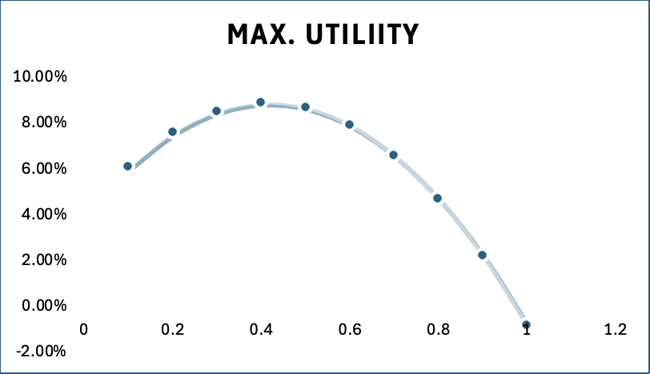
Figure 2: Utility Curve – Maximum Utility Achieved at y = 41.46%

This graph mathematically demonstrates, according to utility theory, why the 41.46% allocation is optimal for the investor with 𝐴 = 5.0, given the characteristics of the risky portfolio and the risk-free asset.

Graph of Indifference Curve vs. Capital Allocation Line (CAL)
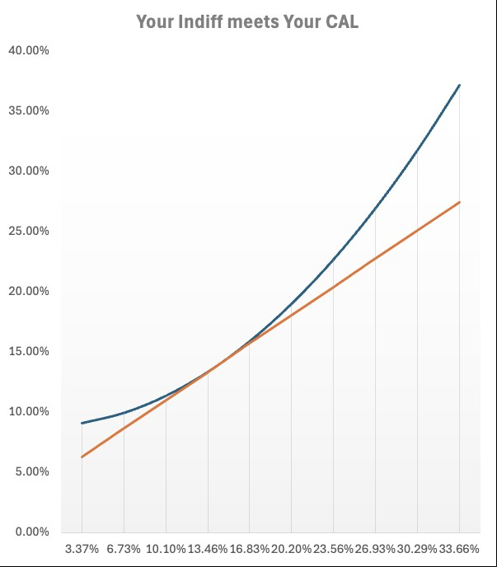
Figure 3: Indifference Curve and Capital Allocation Line (CAL), Tangency Point as Op- timal Portfolio

This graph provides the standard theoretical representation of optimal portfolio choice according to Modern Portfolio Theory. It shows how the investor’s preferences (repre- sented by the map of indifference curves) interact with the efficient opportunities offered by the market (represented by the CAL) to determine the optimal allocation.

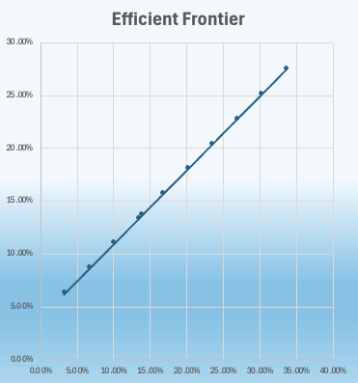
Figure 4: Efficient Frontier of Risky Asset Portfolio

The chart shows the Efficient Frontier which is the set of optimal portfolios that give the highest expected return for a given level of risk. Each point represents a different port- folio of risky assets. The relationship between risk (standard deviation) and expected return is nearly linear as risk increases.

Liquidity, Time Horizon, and Constraints
Time Horizon: The portfolio time horizon extends beyond 20 years because the client is young and accumulating wealth. The long investment period enables investors to handle typical market fluctuations of growth equity investments. The portfolio contains minimal requirements for cash withdrawals during the short and medium period span- ning three to five years. The substantial allocation of 58.54% to T-Bills serves as a liquidity reserve. Any major unexpected requirements must be reported to the Portfo- lio Manager who will evaluate strategy modifications to protect long-term targets. The investment management process will follow the current tax rules of the client’s home country to achieve maximum after-tax returns by implementing strategies such as as- set location and capital gains/losses optimization. A standard tax regime for financial investments is assumed. The portfolio management will follow every law and regula- tory requirement which applies to individual investors in the relevant jurisdiction. The portfolio operates under standard market regulations without any additional restrictions. Emilio Conte has not communicated any distinctive circumstances such as pre-existing

illiquid investments or external wealth concentrations or specific ethical or ESG con- straints that affect portfolio management. Any emerging circumstances need to be incorporated into the IPS.

Asset Allocation & Investment Philosophy

Investment Philosophy
The investment philosophy for this portfolio is based on the principles of Modern Port- folio Theory (MPT) developed by Harry Markowitz (Markowitz, 1952). The goal is to create an efficient portfolio that will get the highest expected return for a certain level of risk (volatility) or the lowest risk for a certain level of expected return. This is done through diversification, combining assets with less-than-perfectly positive correlations to reduce the overall portfolio risk. An active management approach is adopted, par- ticularly for the equity component of the portfolio. Unlike passive management which aims to replicate a benchmark, active management seeks to outperform the benchmark on a risk-adjusted basis. The goal of active management is to generate alpha, an ex- cess return not explained by the systematic risk (beta) undertaken by the portfolio. It is believed that through a disciplined process of fundamental and quantitative analysis, market inefficiencies can be identified, allowing for the selection of specific securities or active management of sector exposures to add value. The chosen investment style is growth investing. This approach focuses on selecting companies that exhibit (or are expected to exhibit) earnings or revenue growth rates significantly above the average for the market or their industry sector. Typical characteristics of growth stocks include:
- High historical and/or expected earnings per share (EPS) growth rates
- Often operating in innovative and rapidly expanding sectors (e.g., technology, biotech)
- Significant reinvestment of profits to fund future growth (often paying low or no dividends)
- Possession of competitive advantages, such as proprietary technology, patents, or strong market leadership
- Potentially high valuations relative to current fundamentals, justified by high future growth expectations
This philosophy (MPT, active, growth) guides the strategic allocation and specific secu- rity selection described below, aiming to capture long-term growth potential in line with the client’s objectives.

Strategic Asset Allocation (SAA)
The Strategic Asset Allocation (SAA) defines the long-term target distribution of capital across major asset classes, representing the most critical decision in determining the portfolio’s risk/return profile over time.

Security Allocation
The equity component of the portfolio, constituting 41.46% of the total allocation, is actively managed. The objective is to outperform the Nasdaq-100 index (via the QQQ ETF), chosen as the benchmark given the growth and technological nature of the invest- ments. The active strategy is implemented through the selection and specific weighting of the following stocks:
Table 1: Active Equity Portfolio Composition

Ticker | Company Name | Target Weight (%) in Active Portfolio
NVDA | Nvidia Corp. | 48.10%
GOOGL | Alphabet Inc. (Class A) | 24.14%
TSM | Taiwan Semiconductor Manuf. | 14.18%
MA | Mastercard Inc. (Class A) | 6.15%
V | Visa Inc. (Class A) | 7.43%
TOTAL |  | 100.0%

The composition of this active portfolio is the direct result of a quantitative analysis and an optimization process described in the underlying analysis. The optimization aimed to construct a portfolio maximizing a risk-adjusted performance measure specific to ac- tive management (likely related to the Information Ratio, given the mention of alpha and residual variance. The extreme concentration in Nvidia (48.10%) and Alphabet (24.14%) is a direct consequence of this optimization, indicating that the analysis at- tributed the highest efficiency in terms of return per unit of specific risk to these two stocks. This suggests that, based on the data analyzed, NVDA and GOOGL offered the best trade-off between expected alpha and idiosyncratic (non systematic) risk. As evident from the composition, the active equity portfolio is heavily concentrated in the Technology sector (semiconductors with NVDA, TSM; software/internet with GOOGL) and related Financial Services (digital payments with V, MA). This focus aligns with the Growth investment philosophy and aims to capitalize on long-term trends like artificial intelligence (AI), cloud computing, advanced semiconductors, and payment digitaliza- tion, expected to drive above-average economic growth.

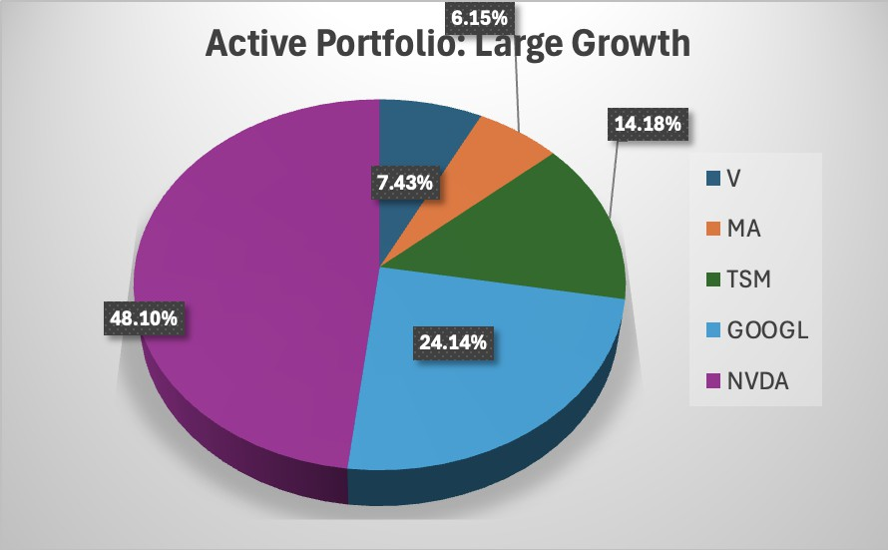
Figure 5: Active Portfolio Composition

Permitted and Excluded Investments
Based on the defined strategy and analysis performed, permitted investments for this portfolio include: Risk-Free Assets: Short-term U.S. Treasury Bills (T-Bills) or equivalent high-credit-quality money market funds. US Large Cap Growth Equity: Common stocks of large-capitalization U.S. companies listed on major exchanges (NYSE, Nasdaq), with a particular focus on those meeting the Growth philosophy criteria. The universe in- cludes, but is not limited to, V, MA, TSM (ADR), GOOGL, NVDA. ETFs (Exchange Traded Funds): ETFs replicating broad market indices (e.g., S&P 500) or specific sec- tors (e.g. QQQ) may be used for managing overall market exposure, benchmarking pur- poses, or as temporary investment vehicles. Investments currently excluded based on the analysis: Long-Term US Bonds: Specifically the TLT ETF and similar instruments, due to the negative expected return identified in the analysis. Other Asset Classes: International Equity (Developed and Emerging), High Yield Bonds, International Bonds, Real Estate (REITs), Commodities, Private Equity, Hedge Funds, Derivatives used for speculative purposes (use of derivatives for risk hedging could be evaluated case by case).

Risk Management and Performance Evaluation

Risk Management
Risk management is an ongoing process aimed at identifying, measuring, monitoring, and controlling the various types of risk the portfolio is exposed to, consistent with the client’s objectives and tolerance.
The approach includes:
- Overall Portfolio Risk (Volatility): Monitored through the Standard Deviation of the complete portfolio (c), with an implicit target of 13.96%, evaluated against the client’s risk tolerance (A=5.0).
- Market Risk (Systematic): Measured and monitored via the portfolio’s Beta () rel- ative to a broad market index (e.g., S&P 500). The complete portfolio’s beta will be approximately 41.46% of the underlying active equity portfolio’s beta. The risk analysis decomposes each stock’s risk into systematic and residual components, providing insight into market sensitivity.
- This risk, tied to individual companies or sectors, is inherently high in this portfolio due to the exclusion of bonds and the concentration in active equity. It is man- aged primarily through the security selection process, which aims to maximize alpha relative to residual risk (as highlighted for NVDA and GOOGL). Diversifica- tion, although limited, is assessed through analysis of correlation and covariance matrices between security returns and residuals.
- Tracking Error: Measures the volatility of the active equity portfolio’s excess re- turn relative to the QQQ benchmark. It will be monitored quarterly to assess the consistency of active management and the magnitude of deviations from the benchmark. A target range for tracking error will be defined based on alpha ex- pectations and market volatility.
- Interest Rate Risk: While direct exposure via bonds is zero (0% allocation to TLT), changes in the risk-free rate (Rf) are monitored as they influence expected returns and the relative valuation of risky assets.
The analysis of Modified Duration (16.20 for TLT) and Convexity (3.42 for TLT), per- formed demonstratively in the underlying analysis, illustrates the standard methodology for quantifying bond price sensitivity to rate changes.115 The price-yield graph for TLT, highlighting the role of convexity, is included below to illustrate this concept:

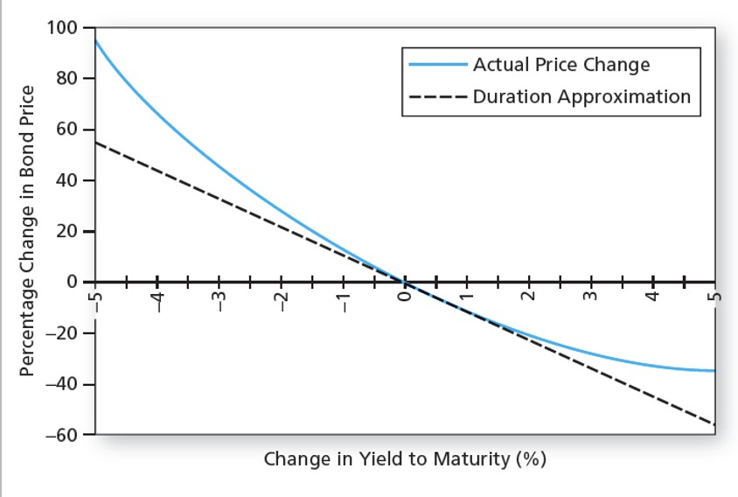
Figure 6: Duration vs. Convexity Impact on Bond Prices
This graph shows how a bond’s price (TLT in this case) changes as interest rates vary. The curved line (blue) represents the actual relationship (including convexity), while the straight line (black dashed) represents the linear approximation given by duration alone. Duration is a good approximation for small rate changes, but the error increases for larger changes. Convexity (positive here) corrects this approximation, showing that the price increases more than predicted by duration when rates fall and decreases less than predicted when rates rise.

Performance Evaluation and Benchmarking
Portfolio performance will be evaluated regularly (quarterly and annually) using multiple metrics, both absolute and relative, to provide a comprehensive view of the results achieved. The performance of the active equity component will be evaluated against the Nasdaq-100 Index, represented by the QQQ ETF. Alpha measures the excess return generated by the manager compared to what the CAPM predicts, given the systematic risk taken (Investopedia, 2025). A positive alpha indicates the manager added value through security selection or other active decisions. The IR assesses the manager’s skill in consistently generating excess returns relative to the volatility of those excess returns. A higher IR suggests greater skill in reliably outperforming the benchmark. Furthermore, a performance attribution analysis will be conducted at least annually to decompose the excess return (or underperformance) of the active equity component relative to the QQQ benchmark.

Performance Evaluation Summary

Table 2: Performance Monitoring Summary

Component | Benchmark | Key Metrics | Reporting Frequency
Overall Portfolio | Target 13.74% | Absolute Return, Sharpe Ra-  tio (Target 0.698) | Quarterly
Active Equity | QQQ (Nasdaq-100) | Relative Return, Jensen’s Al-  pha, Treynor Ratio, Informa- tion Ratio, Performance Attri- bution | Quarterly

Rebalancing Policy
To ensure the portfolio remains aligned with the target Strategic Asset Allocation (SAA), a disciplined rebalancing policy will be applied:
- Monitoring: The portfolio’s actual allocation will be monitored on a quarterly basis.
- Rebalancing Trigger: Rebalancing to the target SAA weights (41.46% Equity and 58.54% Risk-Free) will be triggered if the actual allocation of either main asset class deviates by more than 5% in absolute terms from its target (e.g., if equity exceeds 46.46% or falls below 36.46%).
- Minimum Frequency: Even in the absence of a trigger, the portfolio will be re- balanced at least once per year, typically during the annual Investment Policy Statement (IPS) review.
Rebalancing will consider transaction costs and tax implications, aiming to minimize them. The Portfolio Manager will retain discretion over the exact timing and method of rebalancing, guided by the active strategy and current analysis, but always within the scope of the overall mandate.

Appendix VI.A: Supporting Analysis

Exhibit 1: Capital Allocation

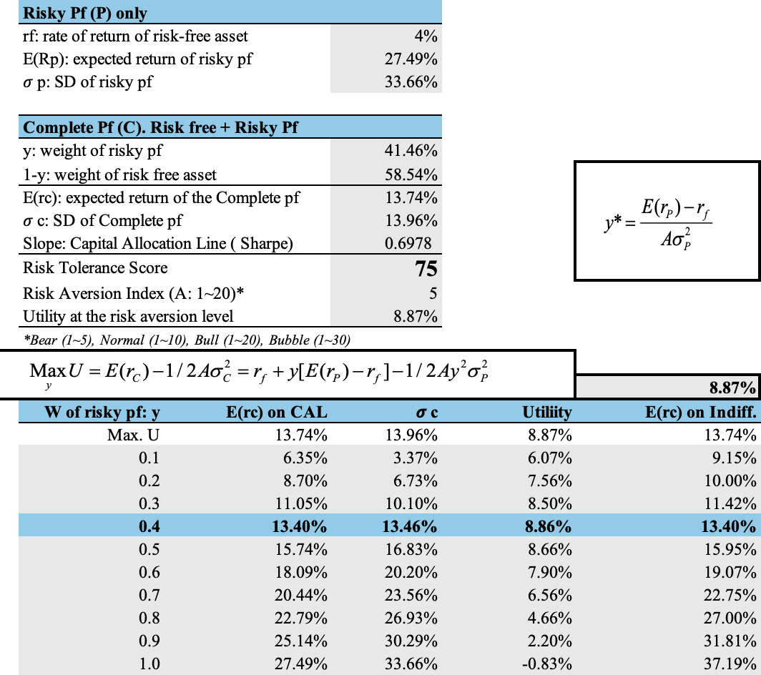

Figure 7: Exhibit 1: Capital Allocation - Optimal Capital Allocation Using Maximum Utility.

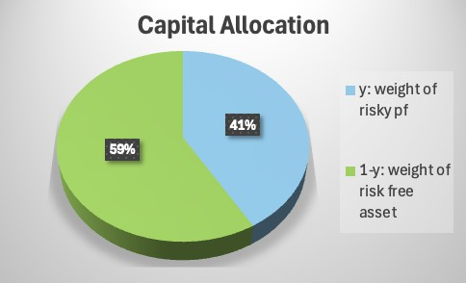
Figure 8: Capital Allocation: Weight of Risky Portfolio and Risk-Free Asset

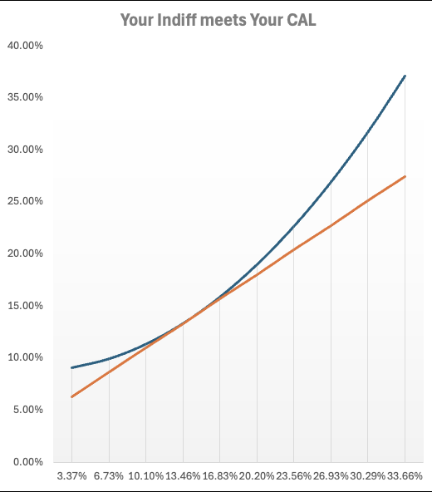
Figure 9: Your Indifference Curve Meets Your Capital Allocation Line (CAL)

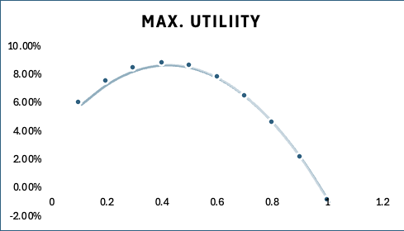
Figure 10: Maximum Utility Curve at Different Risky Portfolio Weights

Exhibit 2: Asset Classes Allocation

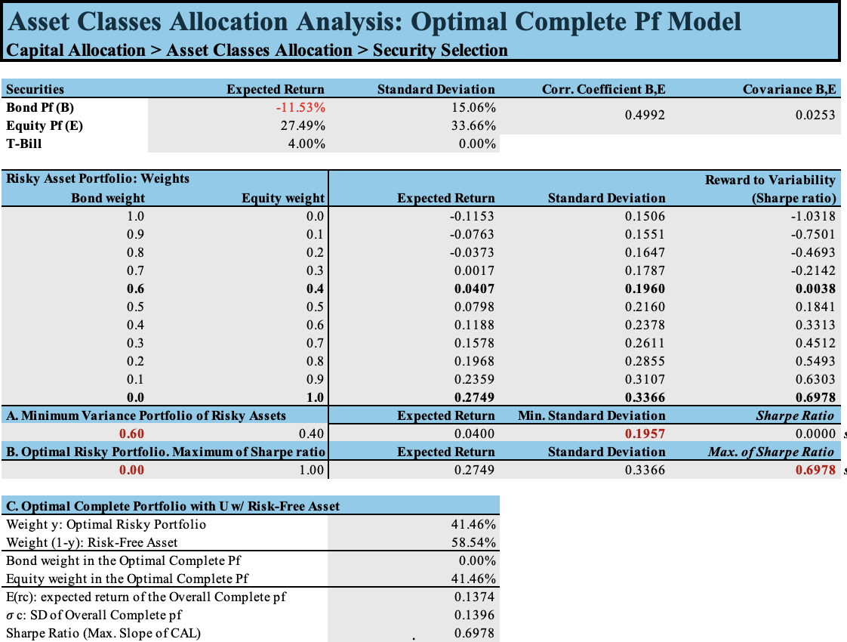
Figure 11: Asset Classes Allocation Analysis: Optimal Complete Portfolio Model


Figure 12: Optimal Complete Portfolio: Composition between Risk-Free Asset and Eq- uity.


Figure 13: Efficient Frontier and Capital Allocation Line with Optimal Risky Portfolio.


Figure 14: Efficient Frontier of Risky Asset Portfolio

Exhibit 3: Security Allocation
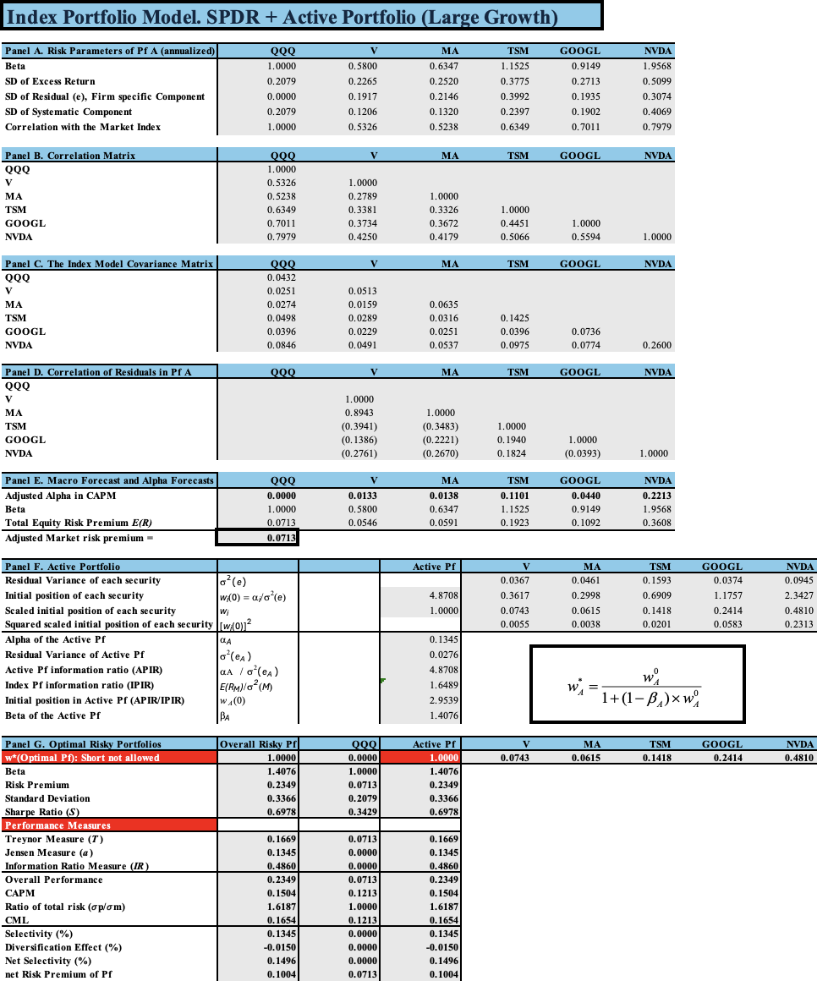

Figure 15: Index Portfolio Model: SPDR and Active Portfolio (Large Growth) including risk parameters, correlations, covariances, and performance measures.

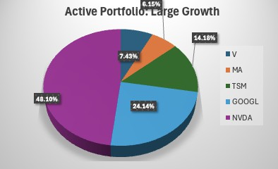
Figure 16: Active Portfolio Allocation for Large Growth securities (V, MA, TSM, GOOGL, NVDA).

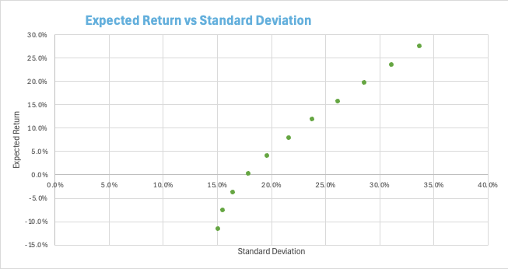

Figure 17: Expected Return vs Standard Deviation of Portfolios

The chart displays how Expected Return relates to Standard Deviation (risk) across var- ious portfolio combinations. The chart demonstrates how standard deviation increases with expected returns because it represents the core relationship between risk and re- turn in portfolio management.
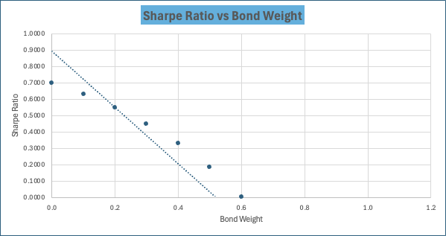

Figure 18: Sharpe Ratio vs Bond Weight

The graph shows the relationship between the bond weight and the Sharpe Ratio in the portfolio. The Sharpe Ratio decreases as the bond weight increases, which means that a higher proportion of bonds results in a lower risk-adjusted return.

Exhibit 4: Data Securities
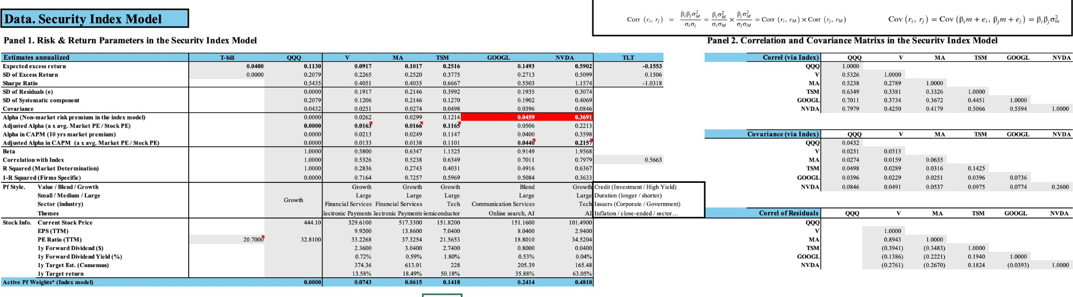
Figure 19: Data Security Index Model: Risk and Return Parameters and Correla- tion/Variance Analysis.

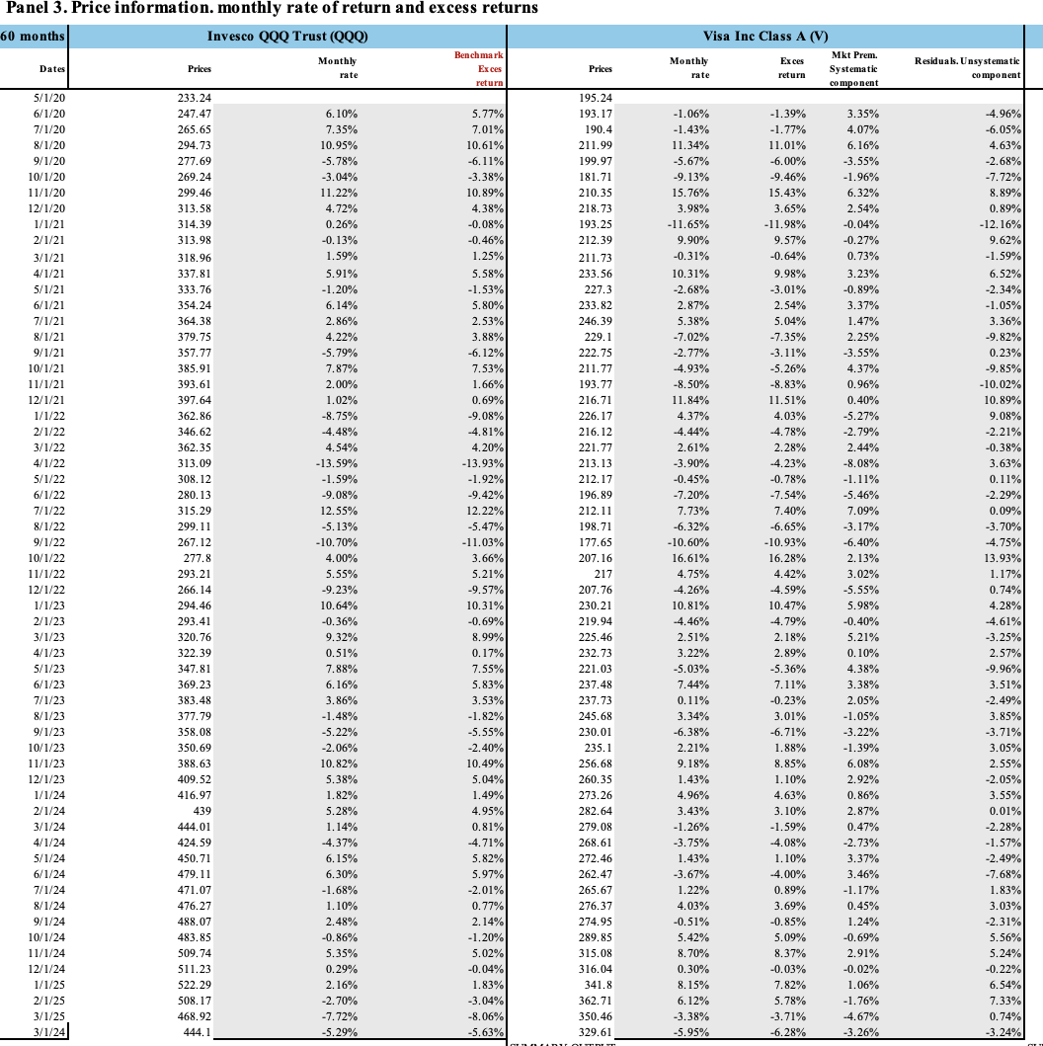
Figure 20: Panel 3 : Monthly Return e Excess Return di Invesco QQQ Trust (QQQ) e Visa Inc. Class A (V).

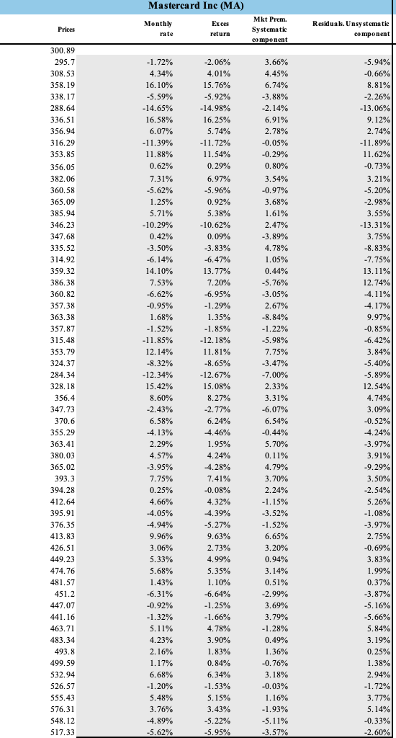

24

Figure 21: Panel 3: Monthly Return e Excess Return di Mastercard Inc. (MA).

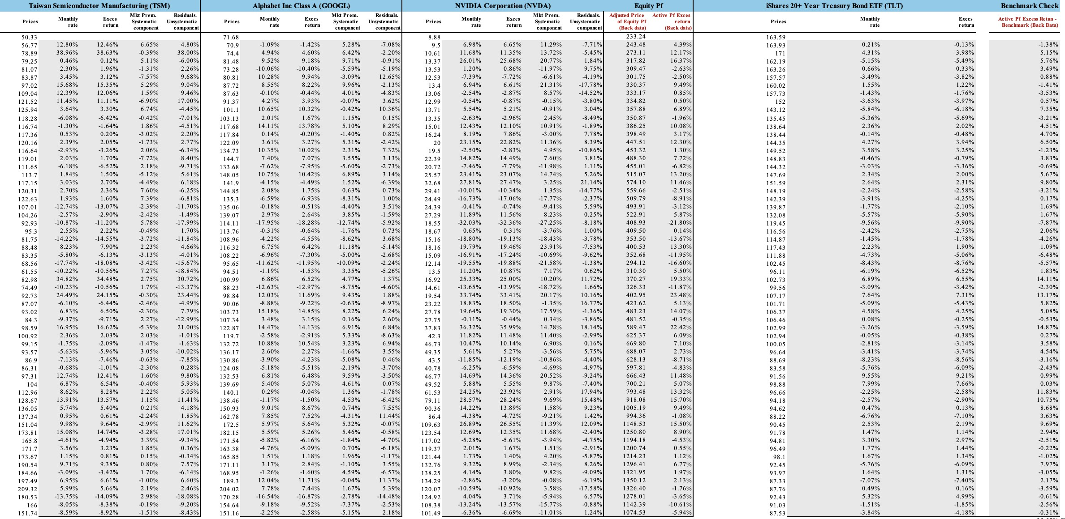
Figure 22: Panel 3 : Monthly Return e Excess Return di TSM, GOOGL, NVDA, TLT e Benchmark Comparison.
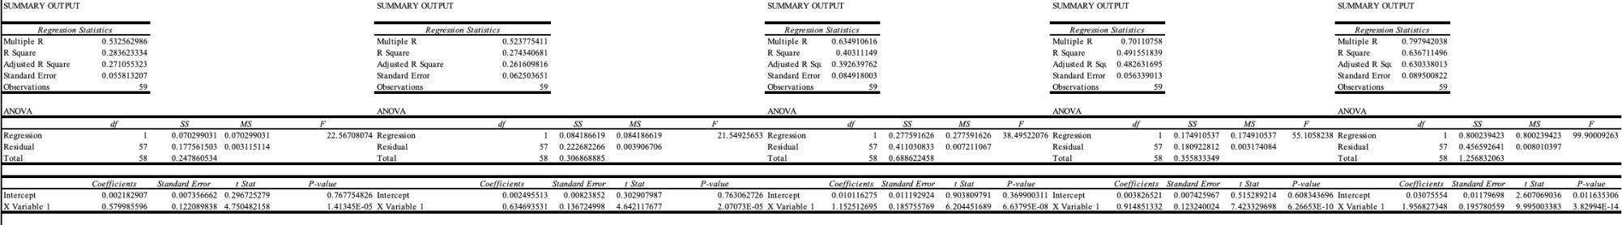

Figure 23: Regression Summary Output and ANOVA Tables for Selected Securities.

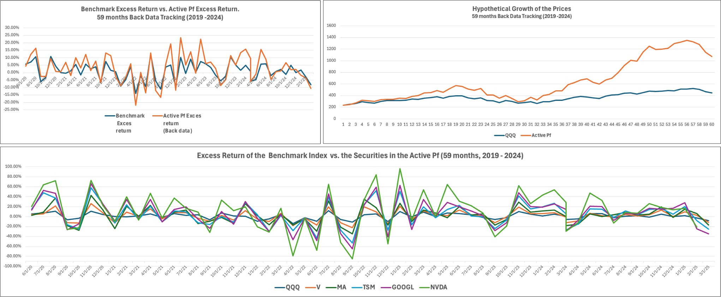
Figure 24: Historical Performance and Excess Return Analysis (59 Months Tracking 2019–2024).

Exhibit 5:Data. Bond Duration & Convexity
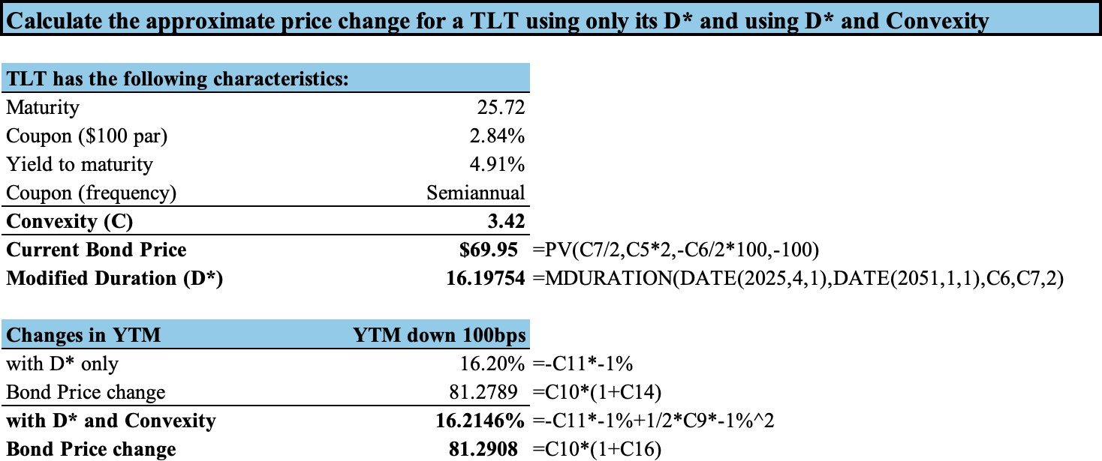

Figure 25: Duration and Convexity Analysis for TLT Bond: Price Sensitivity to YTM Changes.

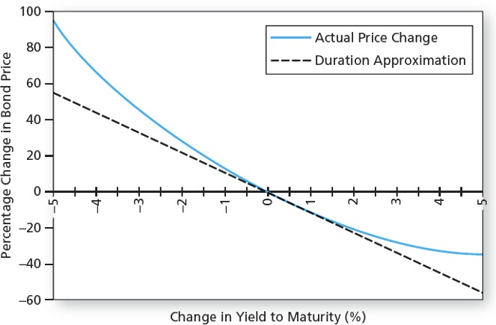
Figure 26: Comparison of Actual Price Change and Duration Approximation for TLT Bond.

References
- CFA Institute. Investment Policy Statement Guidance, Standards of Practice Hand- book, CFA Program Curriculum (Portfolio Management, Equity Valuation, Fixed Income, Quantitative Methods, Ethical and Professional Standards).
- Investopedia. Articles and definitions relating to: Investment Policy Statement, Portfolio Manager Roles, Sharpe Ratio, Risk Aversion, Utility Theory, Capital Allo- cation Line, Efficient Frontier, Growth Investing, Technology Sector Outlook, Beta, CAPM, Systematic and Unsystematic Risk, Tracking Error, Duration, Convexity, Correlation, Covariance, Performance Attribution, Jensen’s Alpha, Treynor Ratio, Information Ratio.
Note: Investopedia is a useful resource for definitions and basic concepts but should be cross-referenced with primary sources for critical analysis; it is gener- ally considered reliable for informational purposes.
- Kroll (Duff & Phelps). U.S. Equity Risk Premium Recommendations.
- Damodaran, A. Data and Analysis. Stern School of Business, New York Univer- sity.
- Morningstar, Inc. Stock Analysis and Ratings (NVDA, GOOGL, V, MA, TSM), Sector Outlooks.
- Gartner, Inc. Technology Sector Forecasts.
- Bloomberg L.P. Market Data and Analysis.
- Markowitz, H. (1952). Portfolio Selection. The Journal of Finance, 7(1), 77–91.
- Sharpe, W. F. (1964). Capital asset prices: A theory of market equilibrium under conditions of risk. The Journal of Finance, 19(3), 425–442.
- Sharpe, W. F. (1966). Mutual fund performance. The Journal of Business, 39(1), 119–138.
- Jensen, M. C. (1968). The Performance of Mutual Funds in the Period 1945–1964. The Journal of Finance, 23(2), 389–416.
- Brinson, G. P., Hood, L. R., & Beebower, G. L. (1986). Determinants of portfolio performance. Financial Analysts Journal, 42(4), 39–44.

Conclusion
This Investment Policy Statement creates a tailored investment approach for Emilio Conte which uses quantitative analysis to match their medium-high risk profile and long time horizon and capital growth objectives. The investment strategy uses active growth management with a 58.54% allocation to risk-free assets and a 41.46% equity portfolio focused on technology/growth stocks (primarily NVDA, GOOGL) which show high alpha potential relative to specific risk. The bond component exclusion stems from negative expected returns in the specific analysis while following a calculated approach to max- imize risk-adjusted return (target Sharpe Ratio 0.698) under the analyzed conditions. The expected return target of 13.74%, with an expected volatility of 13.96%, reflects the ambitious nature of the strategy and the client’s risk tolerance (quantified by A = 5.0). The active management strategy seeks alpha through security selection which uses QQQ as its benchmark. The strategy’s success depends on the accuracy of re- turn and risk assumptions especially for active equity and the ability to control sector and single-stock concentration risks. The defined framework of governance together with risk management and performance evaluation and periodic review serves as the essential foundation for guiding decisions while maintaining client objectives throughout time.

Client Signature: Date:

Portfolio Manager Signature: Date:

Works Cited
- Corporate Finance Institute. "Investment Policy Statement (IPS) - Overview, Components, Example." Accessed April 23, 2025. https:
//corporatefinanceinstitute.com/resources/career-map/sell-side/ capital-markets/investment-policy-statement-ips/
- Investopedia. "Investment Policy Statement (IPS): What It Is and How It Works." Accessed April 23, 2025. https://www.investopedia.com/terms/i/ips.asp
- CFA Institute. "Private Wealth Management." Accessed April 23, 2025. https://www.cfainstitute.org/sites/default/files/-/media/documents/ article/refresher-readings-free/rr-2018-l2v6r47.pdf
- Investopedia. "An Example of an Investment Policy Statement." Accessed April 23, 2025. https://www.investopedia.com/articles/investing/060515/ example-investment-policy-statement.asp
- Morgan Stanley. "The Importance of an Investment Policy Statement." Accessed April 23, 2025. https://www.morganstanley.com/articles/ investment-policy-statement
- Whittier Trust. "5 Reasons Your Investments Need an Investment Policy Statement." Accessed April 23, 2025. https://www.whittiertrust.com/ investment-policy-statement/
- Merrill Lynch. "The Investment Policy Statement is Crucial for Private Foundations and Public Charities." Accessed April 23, 2025. https://pbigaem.fs.ml.com/ articles/the-crucial-role-of-investment-policy-statements.html
- Community Foundation of the North State. "Investment Policy Statement." Accessed April 23, 2025. https://cfnorthstate.org/wp-content/uploads/ 2022/03/CFNS-IPS-approved-03092022.pdf
- CFA Institute. "Investment Policy Statement for Individual In- vestors." Accessed April 23, 2025. https://rpc.cfainstitute.org/ sites/default/files/-/media/documents/article/position-paper/ investment-policy-statement-individual-investors.pdf
- Financial Risk Tolerance: A Psychometric Review, accessed April 23, 2025, https://rpc.cfainstitute.org/research/foundation/2017/financial-risk-tolerance
- What You Should Know When Creating Investment Policy Statements, accessed April 23, 2025, https://www.wealthspire.com/blog/what-you-should-know-when- creating-investment-policy-statements/
- What is a Portfolio Manager? | CFA Institute, accessed April 23, 2025, https://www.cfainstitute.org/programs/cfa-program/careers/portfolio-manager

- Components of the Investment Policy Statement | CFA Level 1 - Analyst- Prep, accessed April 23, 2025, https://analystprep.com/cfa-level-1-exam/portfolio- management/components-of-the-ips/
- Investment Policy Statement: Key Elements and Review Process | Board of Regents, accessed April 23, 2025, https://www.wisconsin.edu/regents/policies/investment-policy-statement-key- elements-and-review-process/
- INVESTMENT POLICY STATEMENT - Regents of the University of California, accessed April 23, 2025, https://regents.universityofcalifornia.edu/regmeet/feb16/i3attach.pdf
- Duff & Phelps U.S. Equity Risk Premium Recommendation Decreased from 5.5% to 5.0%, Effective September 5, 2017 - Kroll, accessed April
23, 2025, https://www.kroll.com/en/insights/publications/cost-of-capital/us-equity- risk-premium-recommendation-2017
- Recommended U.S. Equity Risk Premium and Correspond- ing Risk-Free Rates - Kroll, accessed April 23, 2025, https://www.kroll.com/en/insights/publications/cost-of-capital/recommended-
us-equity-risk-premium-and-corresponding-risk-free-rates
- COE Estimates From Leading Data Sets Are All ’Very Close’, accessed April 23, 2025, https://www.bvresources.com/blogs/bvwire-news/2024/01/19/coe- estimates-from-leading-data-sets-are-all-very-close
- BEFORE THE PUBLIC UTILITY COMMISSION OF OREGON UG
519 OPENING TESTIMONY OF BRADLEY G. MULLINS ON BE- HALF OF THE ALLIANCE OF WESTE, accessed April 23, 2025,
https://edocs.puc.state.or.us/efdocs/HTB/ug519htb335267115.pdf
- What is your risk tolerance in investing? - MassMutual Blog, accessed April 23, 2025, https://blog.massmutual.com/retiring-investing/what-is-risk-tolerance- in-investing
- Subject 2. Risk Aversion and Portfolio Selection - 2025 CFA Level I Exam: CFA Study Preparation, accessed April 23, 2025, https://analystnotes.com/cfa-study- notes-risk-aversion-and-portfolio-selection.html
- Risk Aversion in Portfolio Management | CFA Level 1 - AnalystPrep, accessed April 23, 2025, https://analystprep.com/cfa-level-1-exam/portfolio- management/risk-aversion/
- Capital Asset Pricing Model (CAPM): Definition, Formula, and Assumptions - Investopedia, accessed April 23, 2025, https://www.investopedia.com/terms/c/capm.asp

- Optimal Portfolios in Portfolio Management | CFA Level 1 - AnalystPrep, accessed April 23, 2025, https://analystprep.com/cfa-level-1-exam/portfolio- management/optimal-portfolios/
- Level 1 CFA® Exam: Utility Theory - Soleadea, accessed April 23, 2025, https://soleadea.org/cfa-level-1/utility-theory
- Portfolio Risk and Return: Part I | CFA Institute, accessed April 23, 2025, https://www.cfainstitute.org/insights/professional-learning/refresher- readings/2025/portfolio-risk-return-part-1
- The Risk Aversion Coefficient | Desjardins Online Brokerage - Disnat, accessed April 23, 2025, https://www.disnat.com/en/learning/trading-basics/dbulletin/the- risk-aversion-coefficient
- Coefficient of Variation: Definition and How to Use It - Investopedia, accessed April 23, 2025, https://www.investopedia.com/terms/c/coefficientofvariation.asp

- What | a | Certainty | Equivalent Is, What It Tells You, | How
to | Use | It - | Investopedia, accessed April 23, | 2025,
https://www.investopedia.com/terms/c/certaintyequivalent.asp
- A New Method of Measuring Financial Risk Aversion Using Hy- pothetical Investment Preferences, accessed April 23, 2025, https://digitalcommons.montclair.edu/cgi/viewcontent.cgi?article=1017&context=acctg- finance-facpubs
- Utility function in Portfolio L1 : r/CFA - Reddit, accessed April 23, 2025, https://www.reddit.com/r/CFA/comments/1eldxnt/utility_function_in_portfolio_l1/
- How is risk aversion measured in modern portfolio the- ory (MPT)? - Investopedia, accessed April 23, 2025, https://www.investopedia.com/ask/answers/041615/how-risk-aversion-
measured-modern-portfolio-theory-mpt.asp
- Choosing and Using Utility Functions in Forming Portfolios (Summary), ac- cessed April 23, 2025, https://rpc.cfainstitute.org/research/financial-analysts- journal/2019/ip-choosing-and-using-utility-functions-in-forming-portfolios
- Mean-Variance Optimization – an Overview - CFA, FRM, and Actuarial Exams Study Notes, accessed April 23, 2025, https://analystprep.com/study-notes/cfa- level-iii/mean-variance-optimization-an-overview/
- Risk Averse: What It Means, Investment Choices, and Strategies - Investopedia, accessed April 23, 2025, https://www.investopedia.com/terms/r/riskaverse.asp
- 15.433 INVESTMENTS Class 5: Portfolio Theory Part 3: Optimal Risky Portfolio, accessed April 23, 2025, https://ocw.mit.edu/courses/15-433-investments-spring- 2003/d87bfc38cba412a4187bb892a70fe372_154335portfolio3.pdf

- Basic Portfolio Basic Portfolio Theory, accessed April 23, 2025, http://mba.tuck.dartmouth.edu/bespeneckbo/default/AFA611- Eckbo%20web%20site/AFA611-S3-Portfolio%20Theory.pdf
- Capital Allocation Line (CAL) and Optimal Portfolio - Corporate Finance Institute, accessed April 23, 2025, https://corporatefinanceinstitute.com/resources/career- map/sell-side/capital-markets/capital-allocation-line-cal-and-optimal-portfolio/
- §10. OPTIMAL RISKY AND THE COMPLETE PORT-
FOLIO - Joseph Farizo, accessed April 23, 2025, https://www.josephfarizo.com/files/FIN366Investments/OptimalRiskyPortfolios.pdf

- Deriving | the | risk-aversion | coefficient | - Quantitative Fi-
nance | Stack | Exchange, | accessed | April 23, 2025,
https://quant.stackexchange.com/questions/61966/deriving-the-risk-aversion- coefficient
- Capital Allocation Line - Under30CEO, accessed April 23, 2025, https://www.under30ceo.com/terms/capital-allocation-line/
- Capital Allocation Line (CAL) and Optimal Portfolio - Financial Edge, accessed April 23, 2025, https://www.fe.training/free-resources/portfolio- management/capital-allocation-line-cal-and-optimal-portfolio/
- Efficient Frontier - EdTech Books, accessed April 23, 2025, https://ensign.edtechbooks.org/projectbasedinternship/efficient_frontier
- Capital Market & Allocation Lines | CFA Level 1 - AnalystPrep, accessed April 23, 2025, https://analystprep.com/cfa-level-1-exam/portfolio-management/cal-cml/
- Efficient Frontier and CAL Template - Corporate Finance Institute, ac- cessed April 23, 2025, https://corporatefinanceinstitute.com/resources/financial- modeling/efficient-frontier-and-cal-template/
- How To Plot And Interpret The Efficient Frontier Curve And The Capital Alloca- tion Line, accessed April 23, 2025, https://fastercapital.com/topics/how-to-plot- and-interpret-the-efficient-frontier-curve-and-the-capital-allocation-line.html
- MRS in Economics: What It Is and the Formula for Calculating It - Investopedia, accessed April 23, 2025, https://www.investopedia.com/terms/m/marginal_rate_substitution.asp
- Risk-Adjusted Return Ratios - Definition, Types - Corporate Finance Institute, accessed April 23, 2025, https://corporatefinanceinstitute.com/resources/wealth- management/risk-adjusted-return-ratios/
- Sharpe Ratio: Definition, Formula, and Examples - Investopedia, accessed April 23, 2025, https://www.investopedia.com/terms/s/sharperatio.asp

- Sharpe ratio - Wikipedia, accessed April 23, 2025, https://en.wikipedia.org/wiki/Sharpe_ratio
- What the Sharpe Ratio Means for Investors - Investopedia, accessed April 23, 2025, https://www.investopedia.com/ask/answers/010815/what-good-sharpe- ratio.asp
- Understanding the Sharpe Ratio - Investopedia, accessed April 23, 2025, https://www.investopedia.com/articles/07/sharpe_ratio.asp
- Sharpe Ratio | Definition, Components, Interpretation, Application - Finance Strategists, accessed April 23, 2025, https://www.financestrategists.com/wealth- management/accounting-ratios/sharpe-ratio/
- Portfolio Management: Definition, Types, and Strategies - Investopedia, accessed April 23, 2025, https://www.investopedia.com/terms/p/portfoliomanagement.asp
- Sharpe Ratio, Treynor Ratio, M2, and Jensen’s Alpha - AnalystPrep, ac- cessed April 23, 2025, https://analystprep.com/cfa-level-1-exam/portfolio- management/calculate-and-interpret-the-sharpe-ratio-treynor-ratio-m2-and- jensens-alpha/
- Modern Portfolio Theory: What MPT Is and How In- vestors Use It - Investopedia, accessed April 23, 2025, https://www.investopedia.com/terms/m/modernportfoliotheory.asp
- Protecting Portfolios Using Correlation Diversification - Investopedia, ac- cessed April 23, 2025, https://www.investopedia.com/articles/financial- theory/09/uncorrelated-assets-diversification.asp
- How Is Covariance Used in Portfolio Theory? - Investopedia, accessed April 23, 2025, https://www.investopedia.com/ask/answers/041315/how-covariance-used- portfolio-theory.asp
- How Is Correlation Used in Modern Portfolio Theory? - Investopedia, ac- cessed April 23, 2025, https://www.investopedia.com/ask/answers/030515/how- correlation-used-modern-portfolio-theory.asp
- Investment Philosophy: Definition, Types, and Examples - Investopedia, accessed April 23, 2025, https://www.investopedia.com/terms/i/investment-philosophy.asp
- Attribution Analysis: Definition and How It’s Used for Portfolios - Investope- dia, accessed April 23, 2025, https://www.investopedia.com/terms/a/attribution- analysis.asp
- Alpha: Its Meaning in Investing, With Examples - Investopedia, accessed April 23, 2025, https://www.investopedia.com/terms/a/alpha.asp

- A Deeper Look At Alpha - Investopedia, accessed April 23, 2025, https://www.investopedia.com/articles/financial-theory/08/deeper-look-at- alpha.asp
- Jensen’s alpha - Wikipedia, accessed April 23, 2025, https://en.wikipedia.org/wiki/Jensen%27s_alpha
- Growth Stock: What It Is, Examples, vs. Value Stock - Investopedia, accessed April 23, 2025, https://www.investopedia.com/terms/g/growthstock.asp
- A Beginner’s Guide to Growth Investing - Investopedia, accessed April 23, 2025, https://www.investopedia.com/articles/basics/13/introduction-to-growth- investing.asp
- 7 Simple Strategies for Growing Your Portfolio - Investopedia, accessed April 23, 2025, https://www.investopedia.com/articles/basics/13/portfolio-growth- strategies.asp
- Market Characteristics Not Explained by Traditional Finance - CFA, FRM, and Actuarial Exams Study Notes - AnalystPrep, accessed April 23, 2025, https://analystprep.com/study-notes/cfa-level-iii/market-characteristics-not- explained-by-traditional-finance/
- Value Investing. - CFA, FRM, and Actuarial Exams Study Notes - AnalystPrep, accessed April 23, 2025, https://analystprep.com/study-notes/cfa-level-iii/value- investing/
- Growth at a Reasonable Price (GARP): Definition and Strategy - Investopedia, accessed April 23, 2025, https://www.investopedia.com/terms/g/garp.asp
- Growth Investing: Overview of the Investing Strategy - Investopedia, accessed April 23, 2025, https://www.investopedia.com/terms/g/growthinvesting.asp
- Value versus Growth Investing: Why Do Different Investors Have Different Styles? (Digest Summary), accessed April 23, 2025, https://rpc.cfainstitute.org/research/cfa-digest/2015/11/value-versus-growth- investing-why-do-different-investors-have-different-styles-digest-summary
- Efficient Frontier And Capital Allocation Line - FasterCapital, accessed April 23, 2025, https://fastercapital.com/topics/efficient-frontier-and-capital-allocation- line.html
- V Stock - Visa Stock Price Class A - NYSE - Morningstar, accessed April 23, 2025, https://www.morningstar.com/stocks/xnys/v/quote
- After Earnings, Is Nvidia Stock a Buy, Sell, or Fairly Valued? - Morningstar, accessed April 23, 2025, https://www.morningstar.com/stocks/after-earnings-is- nvidia-stock-buy-sell-or-fairly-valued-2

- GOOGL Stock Price Quote | Morningstar, accessed April 23, 2025, https://www.morningstar.com/stocks/xnas/googl/quote
- MA Stock Price Quote | Morningstar, accessed April 23, 2025, https://www.morningstar.com/stocks/xmex/ma/quote
- MA Stock Price Quote | Morningstar, accessed April 23, 2025, https://www.morningstar.com/stocks/xnys/ma/quote
- Taiwan Semiconductor Manufacturing Co Ltd ADR (TSM) - Morningstar, accessed April 23, 2025, https://www.morningstar.com/stocks/xnys/tsm/quote
- NVDA Stock Price Quote | Morningstar, accessed April 23, 2025, https://www.morningstar.com/stocks/xlim/nvda/quote
- TSMWF Stock Price Quote | Morningstar, accessed April 23, 2025, https://www.morningstar.com/stocks/pinx/tsmwf/quote
- TSMC: Capital Allocation Rating Downgraded to Standard Follow- ing $100 Billion Investment | Morningstar, accessed April 23, 2025, https://www.morningstar.com/stocks/tsmc-capital-allocation-rating-downgraded- standard-following-100-billion-investment
- NVIDIA Stock Price Quote - NASDAQ: NVDA | Morningstar, accessed April 23, 2025, https://www.morningstar.com/stocks/xnas/nvda/quote
- MFS® Growth Fund - Full Holdings, accessed April 23, 2025, https://www.mfs.com/en-us/individual-investor/product-strategies/mutual- funds/full-holdings/MFEIX-mfs-growth-fund-share-I.html
- Mastercard Earnings: Growth Picks Up | Morningstar, accessed April 23, 2025, https://www.morningstar.com/stocks/mastercard-earnings-growth-picks-up
- R-Squared vs. Beta: What’s the Difference? - Investopedia, accessed April 23, 2025, https://www.investopedia.com/ask/answers/012615/whats-difference- between-rsquared-and-correlation.asp
- Alpha and Beta for Beginners - Investopedia, accessed April 23, 2025, https://www.investopedia.com/articles/investing/092115/alpha-and-beta- beginners.asp
- What Beta Means for Investors - Investopedia, accessed April 23, 2025, https://www.investopedia.com/terms/b/beta.asp
- What Is Jensen’s Measure (Alpha), and How Is It Cal- culated? - Investopedia, accessed April 23, 2025, https://www.investopedia.com/terms/j/jensensmeasure.asp
- Systematic Risk: Definition and Examples - Investopedia, accessed April 23, 2025, https://www.investopedia.com/terms/s/systematicrisk.asp

- Systemic Risk vs. Systematic Risk: What’s the Difference? - Investopedia, ac- cessed April 23, 2025, https://www.investopedia.com/ask/answers/09/systemic- systematic-risk.asp
- Active Risk: Overview, Calculations, Examples - Investopedia, accessed April 23, 2025, https://www.investopedia.com/terms/a/activerisk.asp
- Information Ratio - Definition, Formula, and Practical Exam- ple - Corporate Finance Institute, accessed April 23, 2025, https://corporatefinanceinstitute.com/resources/career-map/sell-side/capital- markets/information-ratio/
- Information Ratio (IR): Definition, Formula, vs. Sharpe Ratio - Investopedia, ac- cessed April 23, 2025, https://www.investopedia.com/terms/i/informationratio.asp
- Information ratio - Wikipedia, accessed April 23, 2025, https://en.wikipedia.org/wiki/Information_ratio
- Gartner Forecasts Worldwide GenAI Spending to Reach $644 Billion in 2025 | Morningstar, accessed April 23, 2025, https://www.morningstar.com/news/business-wire/20250331176525/gartner- forecasts-worldwide-genai-spending-to-reach-644-billion-in-2025
- VanEck Blog Rss, accessed April 23, 2025, https://www.vaneck.com/us/en/blogs/rss/
- Technology Sector Is Set To Stay As Safe Haven In 2025: 5 Top Picks | TalkMarkets, accessed April 23, 2025, https://talkmarkets.com/content/stocks– equities/technology-sector-is-set-to-stay-as-safe-haven-in-2025-5-top- picks?post=478164
- InvestTalk | RedCircle, accessed April 23, 2025, https://redcircle.com/investtalk- investment-in-stock-market-financial-planning
- These 15 tech stocks could rocket up to 85% in a year - and analysts love them | Morningstar, accessed April 23, 2025, https://www.morningstar.com/news/marketwatch/20250418165/these-15-tech- stocks-could-rocket-up-to-85-in-a-year-and-analysts-love-them
- Global X S&P 500 Covered Call ETF (XYLD), accessed April 23, 2025, https://www.globalxetfs.com/funds/xyld/
- Technology: Stocks Are Selling Off, Creating More Invest- ment Opportunities | Morningstar, accessed April 23, 2025, https://www.morningstar.com/stocks/technology-stocks-are-selling-off-creating- more-investment-opportunities

- Hang Seng S&P 500 Index ETF - Product Details - ETF - Hang Seng Investment Management Limited, accessed April 23, 2025, https://www.hangsenginvestment.com/en-hk/individual-investor/our-products/etf- listed-details/?TrustNo=H01396&FundClass=B&FundUnit=NA
- How to Create a Correlation Matrix in R - Displayr, accessed April 23, 2025, https://www.displayr.com/how-to-create-a-correlation-matrix-in-r/
- Improved approximation and visualization of the correlation matrix - PMC, ac- cessed April 23, 2025, https://pmc.ncbi.nlm.nih.gov/articles/PMC10691833/
- How to Make a Correlation Matrix in Excel using ChatGPT - Bricks, accessed April 23, 2025, https://www.thebricks.com/resources/guide-how-to-make-a-correlation- matrix-in-excel-using-chatgpt
- What is a Correlation Chart and When Should You Use it? - Luzmo, accessed April 23, 2025, https://www.luzmo.com/blog/correlation-chart
- Correlation Matrix: Understanding Variable Relationships - insightsoftware, accessed April 23, 2025, https://insightsoftware.com/encyclopedia/correlation- matrix/
- Correlation Matrix - Definition, How to Create the Matrix in Ex- cel - Corporate Finance Institute, accessed April 23, 2025, https://corporatefinanceinstitute.com/resources/excel/correlation-matrix/
- Tracking Error - Definition, Formula, and Practical Exam- ple - Corporate Finance Institute, accessed April 23, 2025, https://corporatefinanceinstitute.com/resources/career-map/sell-side/capital- markets/tracking-error/
- Tracking Error Explained with Examples | CFA Level 1 - AnalystPrep, ac- cessed April 23, 2025, https://analystprep.com/cfa-level-1-exam/quantitative- methods/tracking-error-interpretation-example-importance/
- Tracking Error: Definition, Factors That Affect It, and Example - Investopedia, accessed April 23, 2025, https://www.investopedia.com/terms/t/trackingerror.asp
- Duration and Convexity To Measure Bond Risk - Investopedia, accessed April 23, 2025, https://www.investopedia.com/articles/bonds/08/duration-convexity.asp
- Convexity in Bonds: Definition, Meaning, and Examples - Investopedia, accessed April 23, 2025, https://www.investopedia.com/terms/c/convexity.asp
- Convexity Adjustment in Bonds: Calculations and Formulas - Investope- dia, accessed April 23, 2025, https://www.investopedia.com/terms/c/convexity- adjustment.asp

- Convexity - Definition, How it works, Excel Workout - Financial Edge, accessed April 23, 2025, https://www.fe.training/free-resources/portfolio- management/convexity/
- Duration & Convexity - Fixed Income Bond Basics | Raymond James, accessed April 23, 2025, https://www.raymondjames.com/wealth-management/advice- products-and-services/investment-solutions/fixed-income/bond-basics/duration- and-convexity
- How Do I Calculate Convexity in Excel? - Investopedia, accessed April 23, 2025, https://www.investopedia.com/ask/answers/052615/how-can-i- calculate-convexity-excel.asp
- Duration & Convexity of a Bond Portfolio | CFA Level 1 - AnalystPrep, accessed April 23, 2025, https://analystprep.com/cfa-level-1-exam/fixed-income/duration- and-convexity-of-a-bond-portfolio/
- Understanding Bond Convexity - Breckinridge Capital Advisors, accessed April 23, 2025, https://www.breckinridge.com/insights/details/understanding- bond-convexity/
- Approximate Modified Duration and Convexity Adjustment - PrepNuggets, accessed April 23, 2025, https://prepnuggets.com/cfa-level-1-study-notes/fixed- income-study-notes/understanding-fixed-income-risk-and-return/approximate- modified-duration-and-convexity-adjustment/
- Duration and Convexity in Bond market - Macro Hive -, accessed April 23, 2025, https://macrohive.com/hive-explainers/duration-and-convexity-in-bond-markets/
- Treynor Ratio: What It Is, What It Shows, Formula To Calculate It - Investopedia, accessed April 23, 2025, https://www.investopedia.com/terms/t/treynorratio.asp
- Measures of Risk-Adjusted Return:, accessed April 23, 2025, https://rpc.cfainstitute.org/sites/default/files/-
/media/documents/code/gips/measures-risk-adjusted-return.pdf
- Application resources | CFA Institute, accessed April 23, 2025, https://www.cfainstitute.org/membership/become-member/application-resources
- Candidate resources - CFA Institute, accessed April 23, 2025, https://www.cfainstitute.org/programs/candidate-resources
- Portfolio Manager job with Centennial Bank | 9376735 - CFA Institute Career Cen- ter, accessed April 23, 2025, https://careers.cfainstitute.org/job/9376735/portfolio- manager/
- Portfolio Manager II - Homebuilder Finance job with Flagstar Bank | 9391513, accessed April 23, 2025, https://careers.cfainstitute.org/job/9391513/portfolio- manager-ii-homebuilder-finance/

- Investopedia Financial Review Board, accessed April 23, 2025, https://www.investopedia.com/investopedia-financial-review-board-5076269
- V - Visa Inc Class A Valuation | Morningstar, accessed April 23, 2025, https://www.morningstar.com/stocks/xnys/v/valuation
- DuPont Analysis: Definition, Uses, Formulas, and Examples - Investopedia, ac- cessed April 23, 2025, https://www.investopedia.com/terms/d/dupontanalysis.asp
- Credit Rating | EBSCO Research Starters, accessed April 23, 2025, https://www.ebsco.com/research-starters/business-and-management/credit- rating
- NVDA Morningstar Rating : r/ValueInvesting - Reddit, accessed April 23, 2025, https://www.reddit.com/r/ValueInvesting/comments/18vjjfr/nvda_morningstar_rating/
- V - Visa Inc Class A Financials | Morningstar, accessed April 23, 2025, https://www.morningstar.com/stocks/xnys/v/financials
- Alphabet Inc Class A GOOGL - Morningstar, accessed April 23, 2025, https://www.morningstar.ca/ca/report/stocks/quote.aspx?t=0P000002HD
- NVIDIA Corp Chart - NVDA - Morningstar, accessed April 23, 2025, https://www.morningstar.com/stocks/xnas/nvda/chart

